Figures and Tables – Microplastic detection with Quantum Dots

b
a

c

Figure 1: (a) FTIR data of 3-MPA, L-Ascorbic acid co-capped CdTe QDs. (b) UV- visible spectroscopy of 3-MPA, L-Ascorbic acid co-capped CdTe QDs. (c) Raman spectroscopy of 3-MPA, L-Ascorbic acid co-capped CdTe QDs

b
a

d
c
Figure 2: FTIR data of pure, H₂O₂ treated and H₂O₂ + HNO₃ treated (a) PP, (b)PE, (c)PVC, and (d)PS MP particles
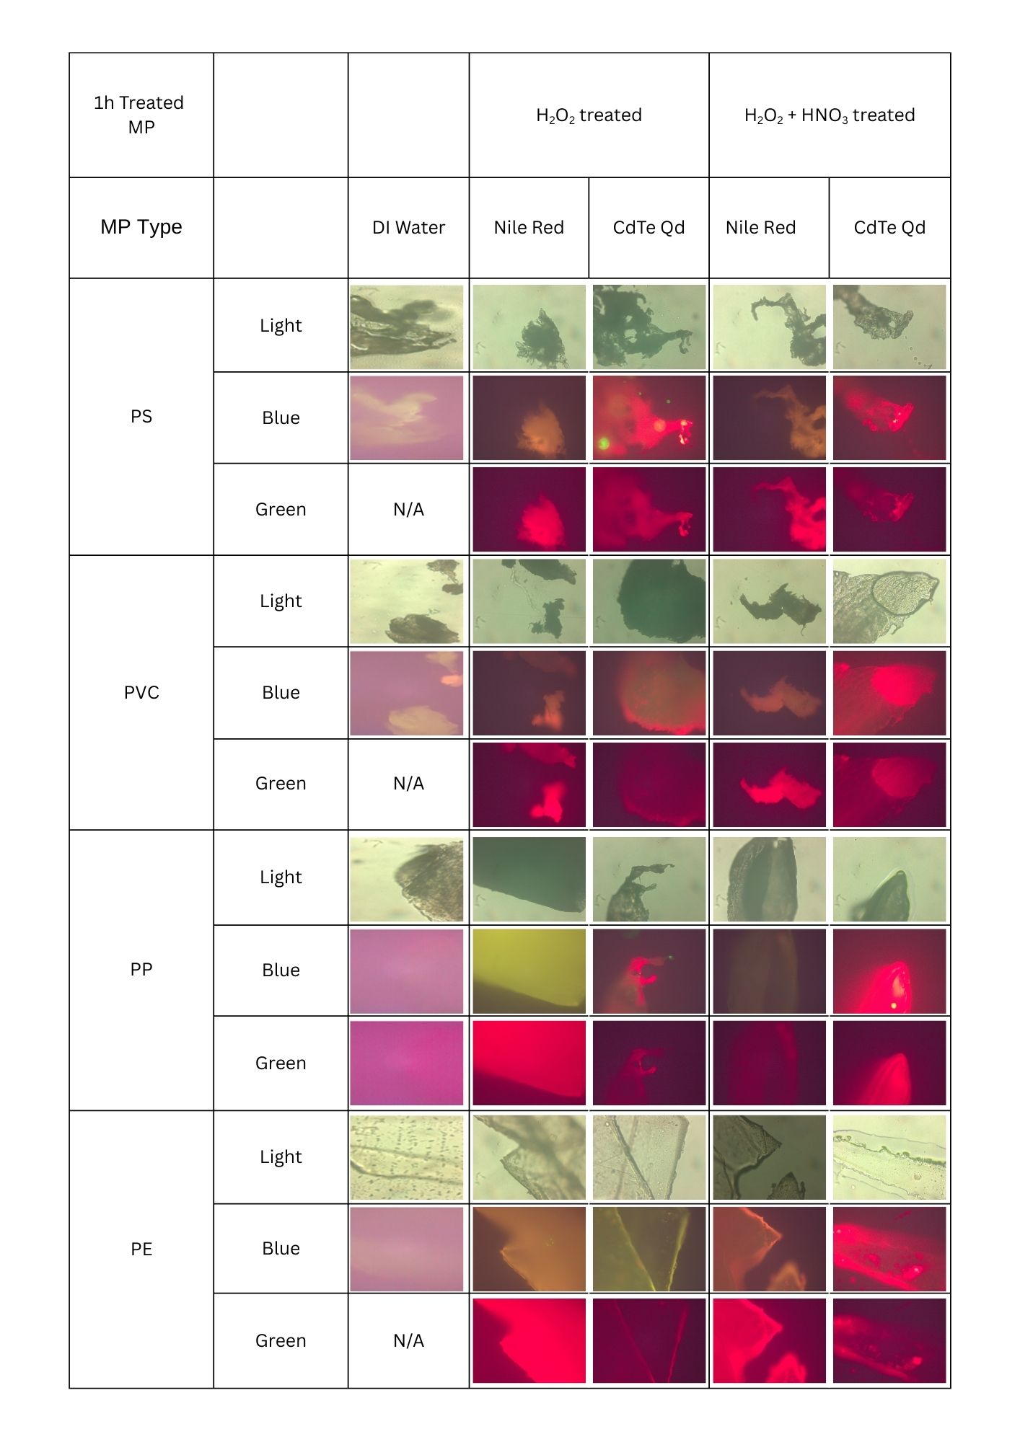
Figure 3: Fluorescence images of microplastic fragments treated with H₂O₂ and H₂O₂ /HNO₃ for 1h, stained with Nile Red and synthesized CdTe QDs, and observed under visible light, blue light filter and green light filter. Images of microplastic fragments in DI water are taken as a reference.
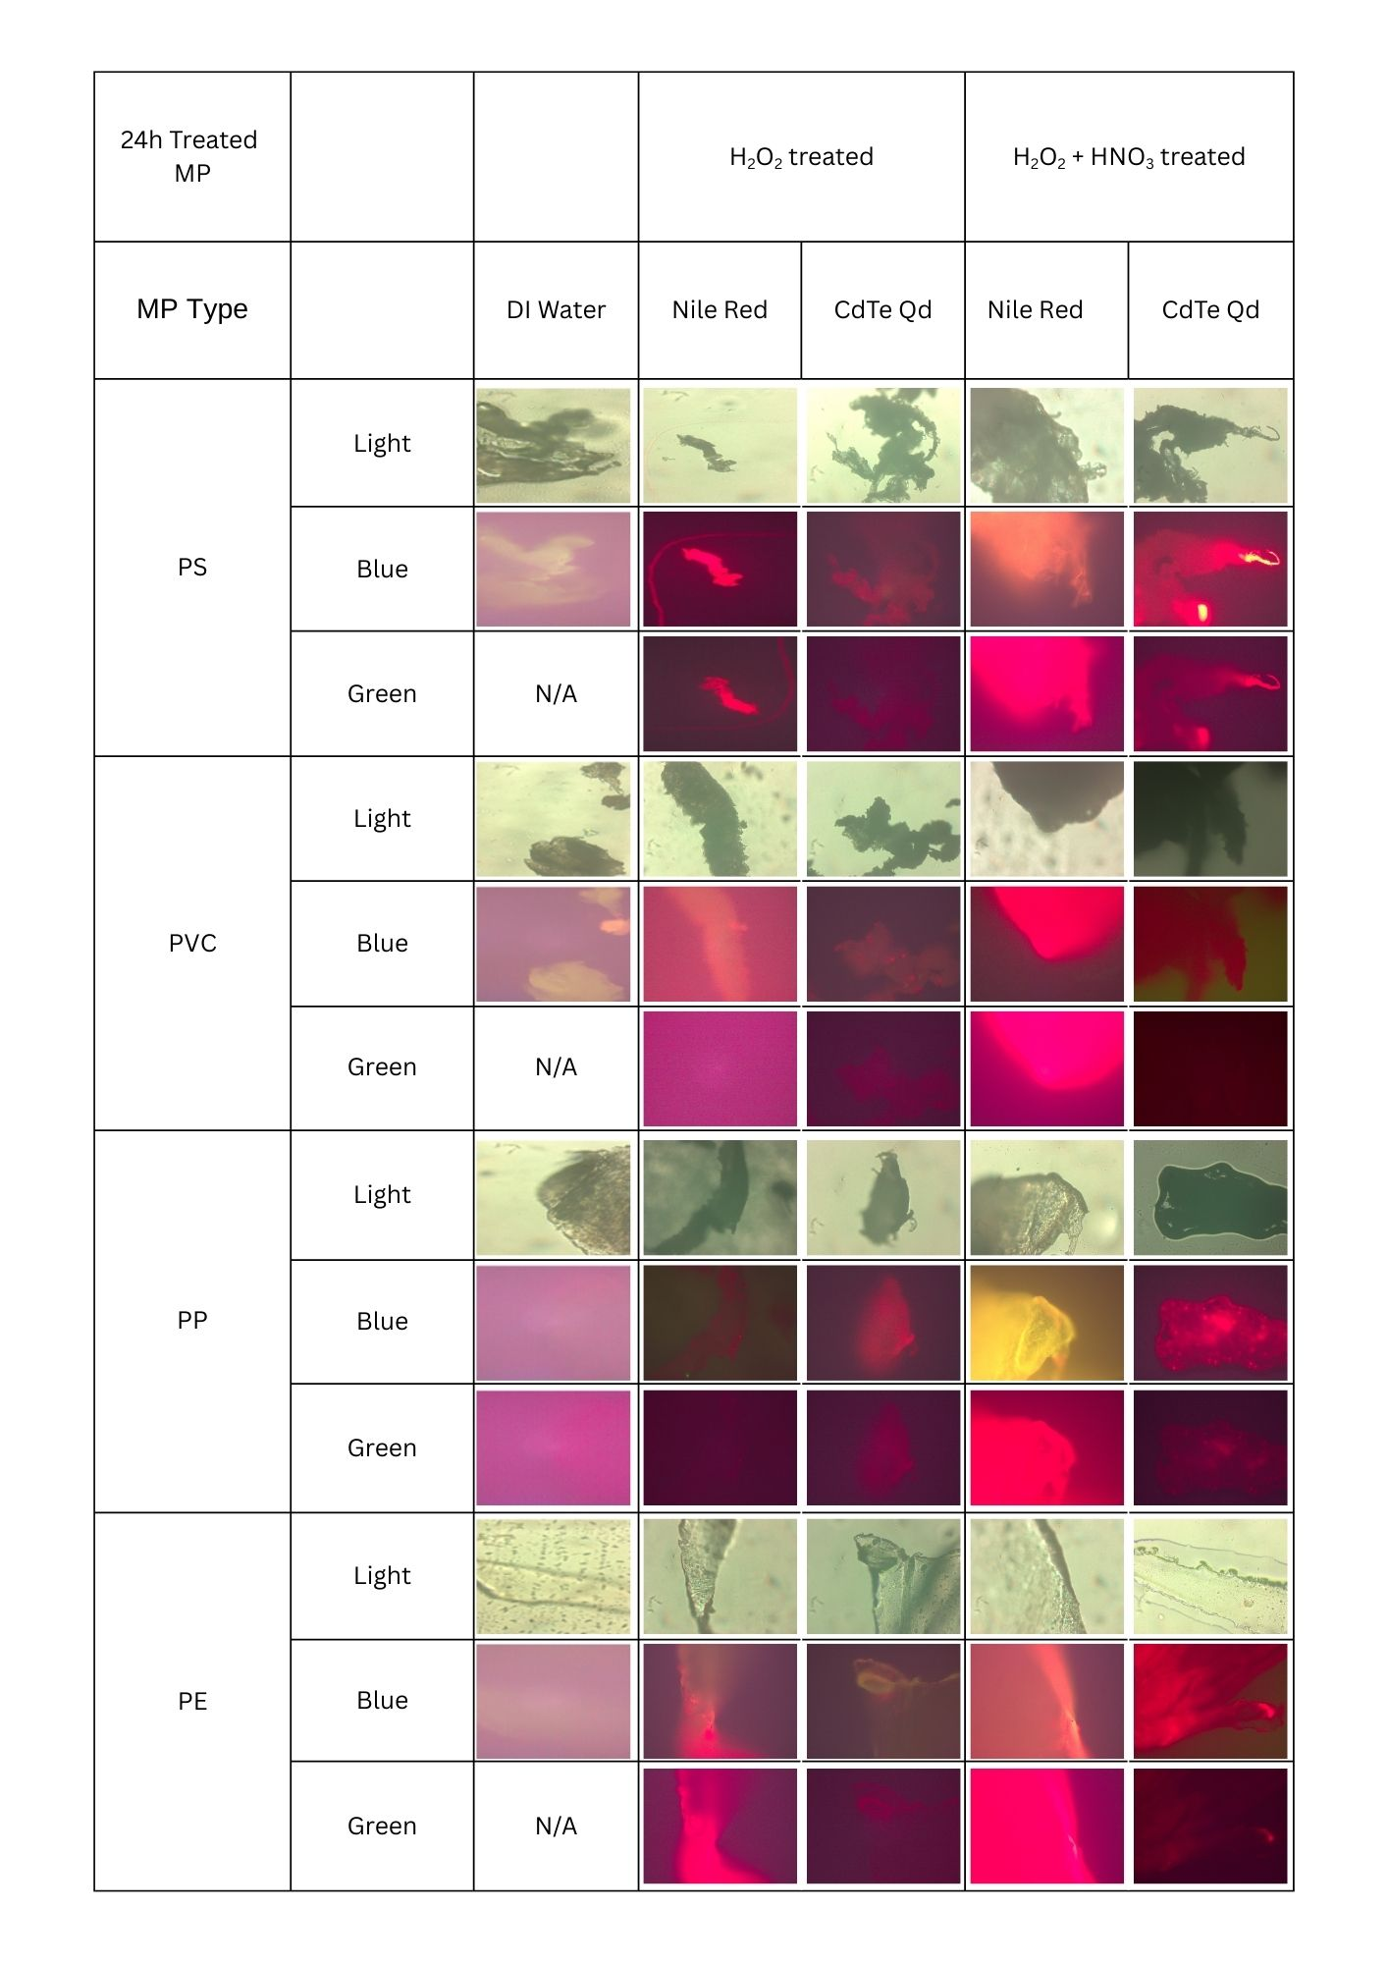 Figure 4: Fluorescence images of microplastic fragments treated with H₂O₂ and H₂O₂ /HNO₃ for 1h, stained with Nile Red and synthesized CdTe QDs, and observed under visible light, blue light filter and green light filter. Images of microplastic fragments in DI water are taken as a reference.
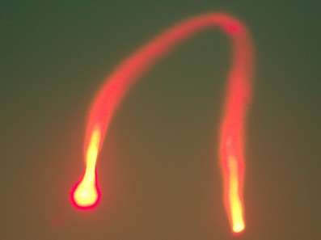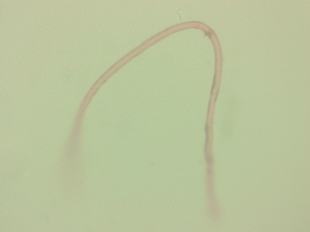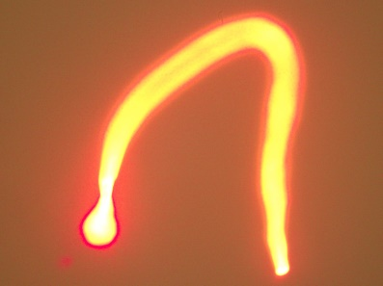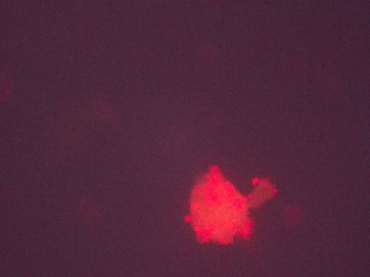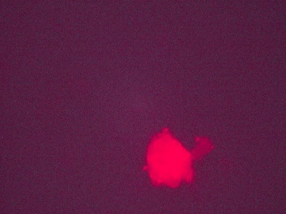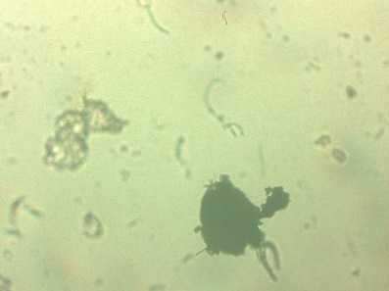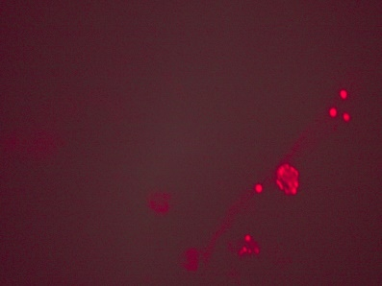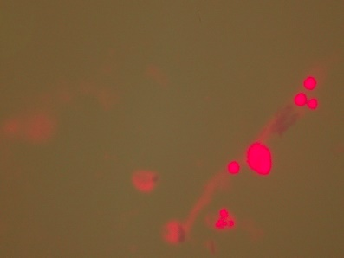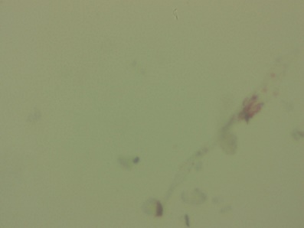
3a
3b
3c
2b
2a
2c
1a
1b
1c

Figure 5: Fluorescence microscopic images of microplastic fragments collected from the water sample taken from (1) central canal of kandy, (Sri Lanka) (2) Kandy Lake, Sri Lanka ; stained with synthesized CdTe QDs, and observed under (a) visible light, (b) blue filter, (c) green filter

