A Novel Analytical Framework for the Rapid Fluorescence Detection of Microplastics Utilizing Highly Photostable CdTe Quantum Dots
W.S. Bowaddeniya¹, T.G.M. Mihidula¹, J.M.S.G.B. Navarathne¹, A. Bandara²,
I.P.L. Jayarathna ¹*
¹Environmental Science Research Program, National Institute of Fundamental Studies, Kandy, 2000 (Sri Lanka)
²Department of Chemistry, University of Peradeniya, Peradeniya, 20500, (Sri Lanka)
E-mail: lakmal.ja@nifs.ac.lk

Abstract

Microplastic (MP) pollution is a growing global concern due to its adverse environmental and human health impacts. However, existing methods for MP detection are often time-consuming and costly. Therefore, modified Cadmium Telluride (CdTe) quantum dots (QDs) were investigated as an alternative fluorescence-based approach for MP detection, addressing key limitation of conventional Nile Red (NR) staining method. Polystyrene (PS), polyethylene (PE), polypropylene (PP), and polyvinyl chloride (PVC) were fragmented (100-200 µm) from consumer products. To enhance binding, microplastics were pre-treated using H₂O₂ /Fenton’s reagent and acid treatment at pH 3. They were incubated with QDs (50 ppm) for 1h and 24h and were observed under a fluorescence microscope. MPs showed the strongest fluorescence after 1h, while longer incubation did not significantly improve fluorescence. CdTe QDs exhibited higher fluorescence intensity and photostability than Nile Red under comparable conditions, demonstrating their potential as a sensitive and efficient qualitative tool for microplastic detection.

Keywords: Microplastics, CdTe quantum dots, Staining, Fluorescence detection

- Introduction

The widespread occurrence of MP (MP) particles (< 5 mm) ¹ in marine, freshwater and atmospheric environment has emerged as a major global environmental concern ^{2,3}. These particles exert both physical and chemical effects on aquatic organisms, altering their health behaviour and overall ecosystem dynamics ^{4,5}. A significant challenge in the field of MPs research is the lack of standardized and affordable methods for MPs detection ^{6,7}.

MPs are typically identified through visual inspection under a microscope ⁸. However, the method exhibits poor reliability, especially in the case of small, transparent, and fibre-type particles ⁹. Microscope-assisted FT-IR and Raman spectroscopy are widely used for chemical identification of MPs ^{10,11,12} Moreover, both methods depend on costly instrumentation and become highly time-consuming when analysing large numbers of particles on a filter paper ⁸. Therefore, the development of robust, sensitive, and standardized analytical methods is crucial to enhance MP identification, bolster large-scale environmental monitoring, and support mechanistic studies on their toxicity, bioaccumulation, and weathering dynamics. Accordingly, fluorescence-based staining methodologies offer the potential to develop high-throughput, cost-effective screening techniques for MP detection and identification, providing a reliable alternative to conventional identification approaches ¹³. The hydrophobic dye Nile Red (NR), which is frequently used in histology, makes it possible to rapidly screen environmental samples using fluorescence, which makes it possible to effective identification and visualization of MPs under a fluorescence microscope ^{14,15}. However, NR exhibits limited chemical and photostability, which can reduce detection reliability and hinder its application in large-scale or long-term monitoring ^{16,17}.

To overcome the limitations associated with conventional dyes such as Nile Red, semiconductor quantum dots (QDs) have emerged as promising alternatives for fluorescence-based MP detection. Unique size-dependent optical and electronic properties, such as highly stable and tunable fluorescence resulting from quantum confinement effects, are exhibited by QDs ¹⁶. Among them, size-tunable photoluminescence, superior water dispersibility, and improved colloidal stability offered by 3-mercaptopropionic acid surface ligands of MPA-capped CdTe QDs have drawn special attention ¹⁸. Despite their potential, the application of QDs for MP detection remains underexplored, and effective strategies to promote strong interactions between QDs and chemically inert polymer surfaces have not been systematically investigated.

This study reports a novel, sensitive, and photostable fluorescence-based method for MP detection using modified 3-MPA and L-Ascorbic acid co-capped CdTe QDs. We investigate the influence of chemical pre-treatment using H₂O₂ and HNO₃ on the binding efficiency and fluorescence intensity of CdTe QDs across four major polymer types (PS, PE, PP, and PVC). The performance of the QD-based method is compared with conventional Nile Red staining, highlighting its potential as a robust tool for high-throughput environmental monitoring and laboratory studies on MP behaviour and toxicity.

- Materials and methods

  - Synthesis of MPA-capped CdTe Quantum Dots

All reagents used in this study were of analytical grade and were utilized without any further purification. Cadmium Chloride (CdCl_{2,} 95%) was purchased from British Drug House (England). Tellurium powder (Te, 100 mesh, ≥99%), Sodium Borohydride (NaBH4, ≥98%), 3-Mercaptopropionic acid (3-MPA, ≥99%), L-Ascorbic acid, Nitric acid (HNO₃, ≥ 98%), Ethanol (≥ 99%), and Tris(hydroxymethyl)aminomethane hydrochloride(Tris-HCl) were purchased from Sigma Aldrich. Nile Red (Nile Blue A Oxane) was purchased from Sisco Research Laboratories (India). Ultrapure water and distilled water were used throughout the synthesis and staining procedures respectively.

Cadmium telluride (CdTe) QDs (QD) were synthesized according to a standard aqueous method with modifications ^{19–21} , using 3-Mercaptopropionic acid (3-MPA) and L-ascorbic acid as capping agents under ambient conditions. NaHTe precursor was prepared under inert conditions in a 1: 4 (v/v) Ethanol: water mixture at a Te: NaBH₄ ratio of 1: 2.5. Cadmium precursor was prepared by dissolving 0.2 mmol of Cadmium Chloride (CdCl₂, 95%) and 3-MPA in 10 ml of ultrapure water and adding 10 ml of 20 mM L- Ascorbic acid to the Cd-MPA complex. The solution was adjusted to a final volume of 40 ml using ultrapure water and the pH of the mixture was adjusted to 11.9 ± 0.1 before NaHTe injection. Systematic variation of reactant ratios for Cd: Te: 3-MPA: AA is 1: 0.1: 1.7: 1 for the optimum growth rate and emission brightness. The reaction mixture was refluxed in open air at roughly 100 °C. The QDs are then precipitated with threefold 0 °C Ethanol and dried at 80 °C to obtain the powder. It is then redispersed in an equal amount of 50 mM Tris-HCl buffer solution to the synthesis mixture, at pH 8.

  - Pre-treatment of MPs and Staining MPs with Quantum Dots

Four polymer types: Polystyrene (PS), Polyethylene (PE), Polypropylene (PP), and Polyvinyl Chloride (PVC) were chosen from consumer products (PS= Polystyrene sheets, PE= Polythene bag, PP= Astra margarine cup, PVC= non-flexible s-lone pipe) and are purchased from the local convenience stores. A stainless-steel scalpel was used to mechanically fragment the plastic materials. Two 100 µm and 400 µm sieves were used to obtain MP fragments in that specific range.

Two MP pre-treatment strategies were employed to enhance binding efficiency. The first involved mixing aqueous solutions of MPs 30% H₂O₂ and Fenton’s reagent in a 1:1 volume ratio, which was used to simulate advanced oxidation and remove organic residues from particle surfaces. Fragmented MPs are sieved to obtain particles in the size range of 100 – 400 µm. Approximately 10 mg of each MP type (PS, PE, PP, and PVC) was immersed in a glass bottle with 100ml of distilled water and 10 mL of H₂O₂/Fenton solution was added. It is then sealed and heated at 60 °C for 6 h under gentle stirring ²². The samples were then filtered and thoroughly rinsed with deionized (DI) water until a neutral pH was achieved and dried at room temperature.
In the second method, the H₂O₂ treated MPs were then treated with diluted nitric acid (0.1 M HNO₃) to mimic environmentally aged surfaces that have oxygen-containing functional groups ²³. Briefly, 0.1 g of MPs was dispersed in 10 mL of 0.1 M HNO₃ (final pH ≈ 3) and stirred for 10 min at room temperature. The particles were subsequently washed several times with DI water until neutral pH and dried at room temperature.
A study was conducted to see whether HNO₃ treatment breakdowns the plastic polymer or causes chain scissions over time. A known number of HNO₃ treated MP particles of each polymer were placed on a separate glass slide with a drop of distilled water and observed under an optical microscope. The particle count and particle sizes were analysed for the same slide in the time periods of 1 h, 24h, and a week to see whether any noticeable size or particle count changes occur.

The pre-treated MPs were incubated with CdTe QDs (100 µg/mL stock solution) for 1 h and 24 h to promote surface binding. Fluorescence characteristics were examined using a fluorescence microscope under blue (515 nm) and green (540 nm) filters, confirming a distinct emission response. All experiments were performed in triplicate, and the detection performance was compared with the Nile Red (100 µg/mL stock solution) staining method.

2.3 Characterization

The optical properties of the synthesized CdTe QDs were examined using UV–Vis spectroscopy to monitor their absorption features. FTIR analysis was performed to identify surface functional groups of the QDs as well as to compare chemical changes in treated and untreated MPs. Raman spectroscopy was used to assess the vibrational characteristics of the CdTe nanocrystals. Finally, fluorescence microscopy was used to confirm the binding of CdTe QDs to pre-treated MPs based on their emitted fluorescence.

- Results and discussion

Fluorescence microscopic images were taken from an Optika (Italy) model B383FL fluorescence microscope, fitted with blue (460 - 495 nm) and green (510 – 550 nm) filter sets. UV-Visible absorbance spectra were recorded using a Shimadzu UV 2450 spectrophotometer equipped with UV Probe software. Centrifugation was carried out using the Thermo Sorvall Legend XTR Refrigerated centrifuge. A model MB3000, ABB Fourier transform infrared (FTIR) spectrophotometer was used in functional group analysis of plastics and CdTe QDs. Raman spectroscopy was performed using a Reinshaw inVia Raman microscope with a 785nm laser source. Scanning electron microscopy (SEM) images were obtained with Hitachi SU6600 instrument operated at 10-15kV. A vacuum filtration setup with Millipore® filter membranes was used with the staining procedure of MPs.

3.1 Characterization of synthesized CdTe Quantum Dots

(a)

(b)

(c)

Figure 1: (a) FTIR data of 3-MPA, L-Ascorbic acid co-capped CdTe QDs. (b) UV- visible spectroscopy of 3-MPA, L-Ascorbic acid co-capped CdTe QDs. (c) Raman spectroscopy of 3-MPA, L-Ascorbic acid co-capped CdTe QDs

The FTIR spectrum of the QDs displayed (figure 1.a) distinct vibrational bands at 3288 cm⁻¹, 1545 cm⁻¹, and 1391 cm⁻¹ ²⁴. The broad band around 3200 - 3300 cm⁻¹ can be attributed to the O–H stretching vibrations, indicating the presence of hydroxyl groups, which likely arise from ascorbic acid moieties on the surface. The peak at 1543 cm⁻¹ corresponds to asymmetric stretching vibrations of the –COO⁻ groups, and this suggests successful coordination of carboxylate functionalities from MPA with the QD surface. Additionally, the band observed at 1391 cm⁻¹ is assigned to symmetric stretching vibrations of carboxylate groups. This further supports the incorporation of MPA as a stabilizing ligand. Collectively, these signals confirm the binding of both hydroxyl and carboxyl functionalities to the QD surface, consistent with effective capping.

Figure 1 (b) shows the UV absorption spectrum of CdTe QDs synthesized using 3-MPA and L-ascorbic acid as capping agents with a synthesis time of 60 min. The pristine QDs displayed a clear absorption maximum at 288 nm (λmax), attributed to the electronic transition arising from quantum confinement.

Figure 1 (c) shows the Raman spectrum of CdTe QD in powder form. This spectrum showed the longitudinal optical (LO) phonon mode at a frequency of 165 cm⁻¹, while the weak feature near ~ 330 cm⁻¹ corresponds to the second-order LO phonon mode. These vibrational modes are characteristic of CdTe and have been widely reported in CdTe-based materials ²⁵.

These results provide strong evidence that the synthesized QDs were successfully stabilized through dual capping with MPA and ascorbic acid. The coexistence of hydroxyl and carboxyl functional groups on the QD surface is expected to enhance colloidal stability ²⁶, facilitate dispersion in aqueous environments, and promote favourable interactions with polymeric substrates in subsequent applications.

3.2 Chemical Pre-treatments of MPs
a
b

c
d

Figure 2: FTIR data of pure, H₂O₂ treated and H₂O₂ + HNO₃ treated (a) PP, (b)PE, (c)PVC, and (d)PS MP particles
FTIR spectroscopy was employed to investigate the chemical modifications induced on the surfaces of polypropylene (PP), polyethylene (PE), polyvinyl chloride (PVC), and polystyrene (PS) following oxidative pretreatment using H₂O₂/Fenton reagent and dilute HNO₃. Comparative analysis of untreated and treated MPs revealed pronounced changes in surface functional chemistry, confirming successful oxidation and surface activation.
For most MPs analysed (PET, LDPE, and PP), the dominant feature observed after acid treatment was the appearance of a broad O–H stretching band, indicating surface hydroxylation. This observation suggests that acid treatment induces mild oxidation, resulting in the formation of hydroxyl groups on the polymer surface. Such modifications are consistent with the increased fluorescence response previously observed in microscopy studies using QDs, as hydroxyl and carboxyl functionalities provide favourable sites for QD interaction.
The FTIR spectrum of untreated PP (figure 2.a) is characterized by dominant aliphatic C–H stretching vibrations at 2950–2850 cm⁻¹ and CH₂ and CH₃ bending modes near 1455 cm⁻¹ and 1375 cm⁻¹, consistent with its saturated hydrocarbon backbone ²⁷. Following H₂O₂/Fenton treatment, the spectrum shows no distinct emergence of new functional groups, indicating negligible chemical modification under these conditions. In contrast, HNO₃-treated PP exhibits subtle but detectable spectral changes, including a slight broadening in the 3200–3500 cm⁻¹ region, suggesting limited hydroxyl group formation. Although these features are weak, their presence indicates mild surface oxidation detectable only after HNO₃ treatment, reflecting the oxidative capability of nitric acid toward chemically inert polyolefins.
Untreated PE exhibited (figure 2.b) characteristic –CH₂ asymmetric and symmetric stretching bands at 2916 and 2849 cm⁻¹ respectively, along with bending vibrations near 1470 and 720 cm⁻¹ ²⁸. Similar to PP, H₂O₂/Fenton-treated PE shows no significant deviation from the untreated spectrum, confirming minimal surface oxidation. However, after HNO₃ treatment, a weak carbonyl absorption band near 1715–1730 cm⁻¹ becomes observable, accompanied by a slight increase in baseline intensity in the hydroxyl stretching region. These spectral changes, although modest, demonstrate that HNO₃ induces a higher degree of surface activation than H₂O₂/Fenton, even in highly crystalline and nonpolar PE.
PVC exhibits greater susceptibility to chemical modification compared to polyolefins. Untreated PVC spectra (Figure 2.c) show characteristic C–H stretching vibrations and a prominent C–Cl stretching band in the 600–700 cm⁻¹ region ²⁹ . Following H₂O₂/Fenton treatment, a weak and broad O–H stretching band near 3400 cm⁻¹ appears, indicating limited hydroxyl group formation. Notably, HNO₃-treated PVC shows a more pronounced increase in O–H band intensity. These changes suggest partial dehydrochlorination and oxidative surface aging that results in a higher density of oxygen-containing functional groups compared to H₂O₂/Fenton treatment.
Following H₂O₂/Fenton treatment, the FTIR spectrum of PS exhibits no distinct new absorption bands attributable to oxygen-containing functional groups (Figure 2.d). Similarly, HNO₃-treated PS fragments do not show any distinct or well-resolved spectral changes compared to untreated and H₂O₂-treated samples.
HNO₃ treatment did not seem to cause any deterioration of the plastic polymer over time as observed through the optical microscope. The observed particle count and the size stayed relatively the same. Hence, it can be assumed that the used concentration of HNO₃ and treatment durations only modify the plastic surface without damaging the polymer structure.
The increased density of oxygen-containing functional groups provides multiple anchoring sites for MPA-capped CdTe QDs, facilitating stronger electrostatic attraction, hydrogen bonding, and improved interfacial compatibility. These FTIR findings directly correlate with the higher fluorescence intensities observed for HNO₃-treated MPs during QD staining, particularly for PP and PE, which otherwise show weak affinity toward conventional fluorescent dyes. Overall, the FTIR results confirms that controlled chemical pretreatment with dilute HNO₃ is an effective and a viable strategy for the modification of MP surfaces. By enhancing nanoparticle adhesion, this approach ensures more consistent and reliable results in fluorescence-based MP detection.

3.3 Comparative Evaluation of Surface Modification and QD Binding Efficiency Towards Fluorescence Based MP Detection

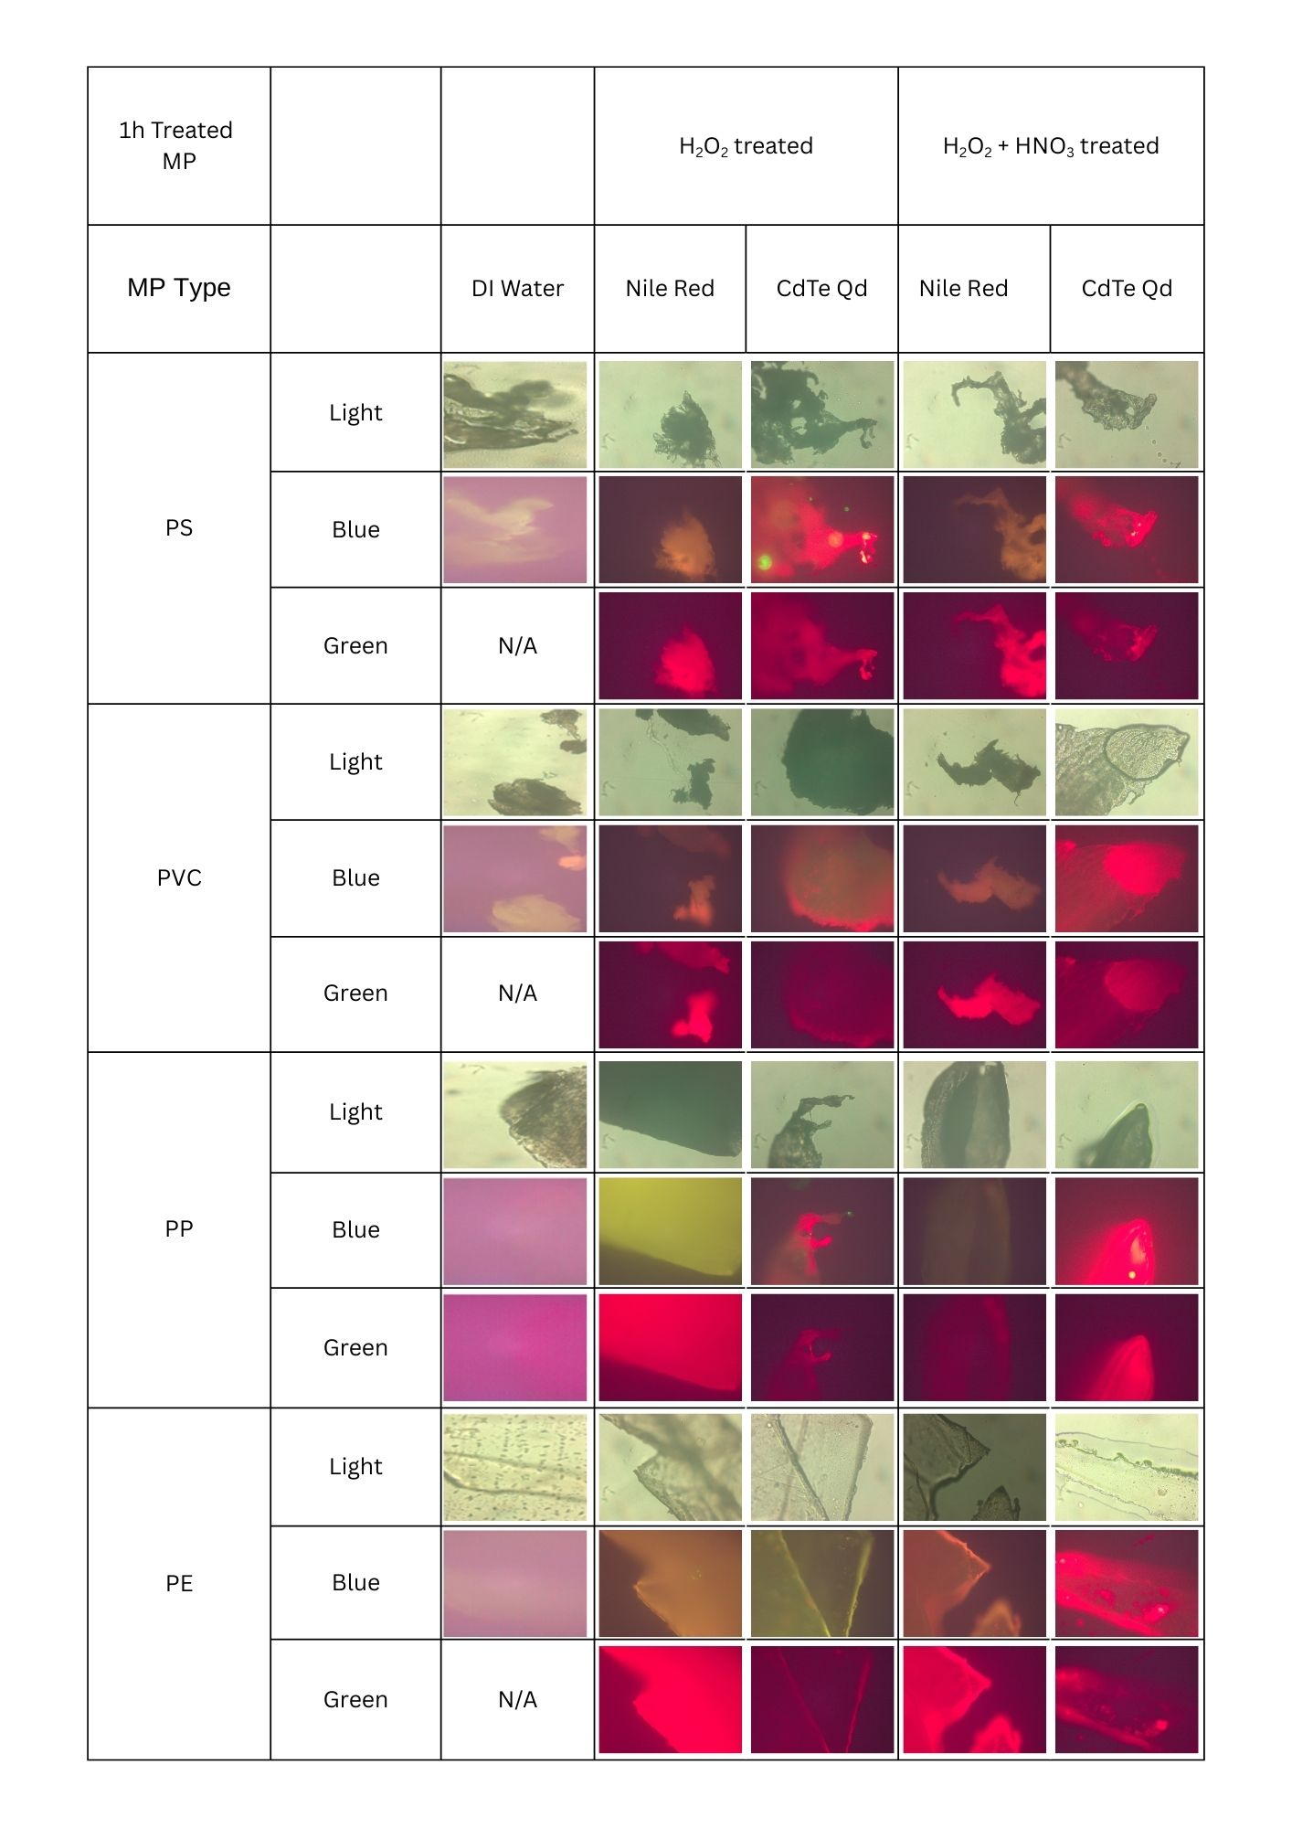
Figure 3: Fluorescence images of MP fragments treated with H₂O₂ and H₂O₂ /HNO₃ for 1h, stained with Nile Red and synthesized CdTe QDs, and observed under visible light, blue light filter and green light filter. Images of MP fragments in DI water are taken as a reference.
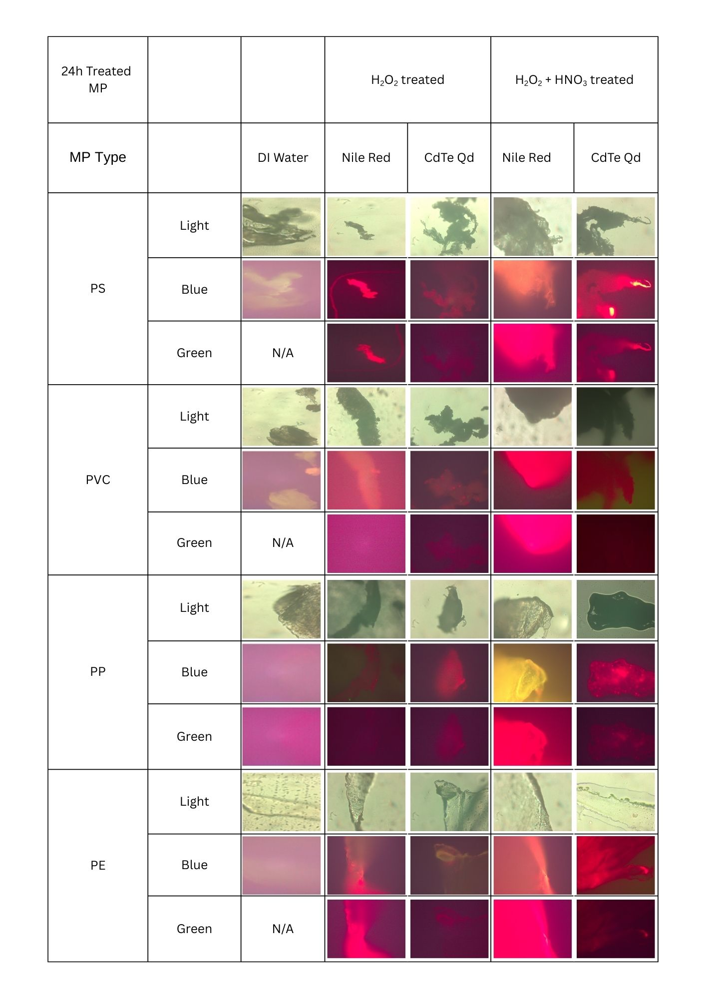 Figure 4: Fluorescence images of MP fragments treated with H₂O₂ and H₂O₂ /HNO₃ for 1h, stained with Nile Red and synthesized CdTe QDs, and observed under visible light, blue light filter and green light filter. Images of MP fragments in DI water are taken as a reference.
Fluorescence microscopy is used to examine the binding efficiency of CdTe QDs to pre-treated MPs at 20× magnification with the use of blue and green excitation filters. The labeling performance of CdTe QDs was compared to that of Nile Red. Following the pre-treatment, MPs incubated with CdTe QDs showed varying fluorescence behaviors across the polymer type. Fluorescence signals were observable under both blue and green filters after each incubation, with generally stronger responses detected in the blue channel. However, fluorescence intensities varied according to the treatment method (H₂O₂ vs H₂O₂/HNO₃) and the length of the incubation period (1h and 24h), even within the same polymer type.
In H₂O₂/HNO₃- treated samples, particularly for PE and PS, the QD stained MPs exhibit intense, saturated reddish fluorescence under the blue filter. The signal-to-noise ratio appears superior as the QDs provide a good contrast against the background. While Nile Red staining shows high intensities under the green filter, it often results in a broad, smothered fluorescence. In contrast, the QDs seem to adhere well to the surface alterations and make the fluorescence signals from the stained MP particles appear more clarified.
The treatment of pure plastic fragments with H₂O₂/HNO₃ simulates the oxidative weathering and physical degradation found in environmental samples. The CdTe QDs show a high affinity for these induced surface alterations. In the PE and PVC rows, the QDs adhere predominantly to the rugged edges and fractured surfaces of the fragments and highlight them under the blue filter. This is less distinct in the images taken with Nile Red. Therefore, it can be suggested that the QDs effectively map and provide a more detailed “topographical” view of the MP surface, whereas Nile Red tends to partition more generally into the polymer matrix because of its lipophilic nature.
In contrast to H₂O₂ treatment, H₂O₂/HNO₃ treated MPs exhibited better and consistent fluorescence signals when labeled with QDs. A significant improvement is observed in PE after the H₂O₂/HNO₃ treatment, in both 1h and 24h incubation tables. PE particles stained with QDs show a dramatic increase in binding density and fluorescence intensity following HNO₃ treatment compared to the H₂O₂ only treatment. This enhanced labeling efficiency can be attributed to more effective surface oxidation, which likely introduces oxygen-containing functional groups that promote electrostatic and coordination interactions with the QDs.
It is noted that Nile Red maintains strong performance for PP and PE under the green filter, likely due to its lipophilic nature. However, the QD method remains a viable alternative here, which offers a better, localized fluorescence under blue filter and avoiding over saturation.
Extending the incubation period to 24 hours does not seem to significantly improve the results, in fact, extended incubation resulted in a noticeable attenuation of the fluorescence signal. While 1h incubation yielded a vibrant, bright red emission, 24h led to a shift toward a darker, muted red signal with dimmed brightness.
The comparison confirms that while Nile Red staining is relatively static regardless of the pretreatments, the QD staining method is dependent on chemical and physical surface alterations of the plastic. Hence, QD staining can be an effective alternative in identifying microplastics in environmental samples, as well as in identifying aging and weathering patterns on their surfaces.

3.4 Application of field samples

The optimized methodology (HNO₃ pre-treatment followed by 1-hour incubation with CdTe QDs) was tested on an environmental water sample to determine practical applicability. Fluorescence microscopy at ×20 magnification was used to assess the particulate matter in the sample after treatment.

.
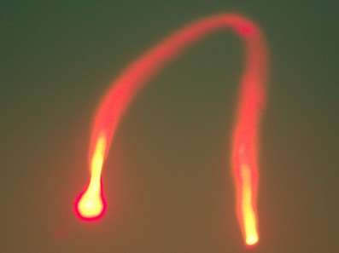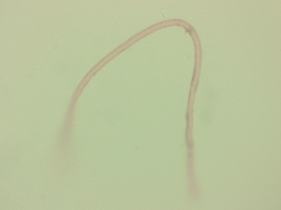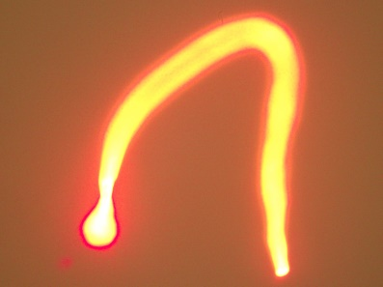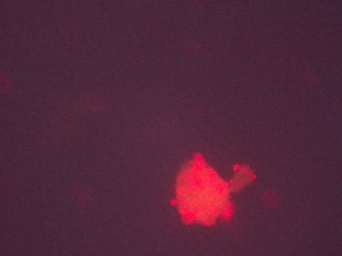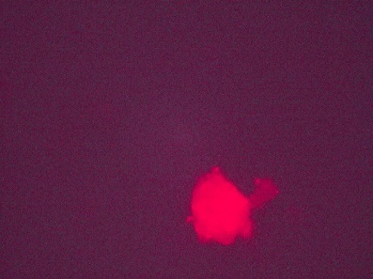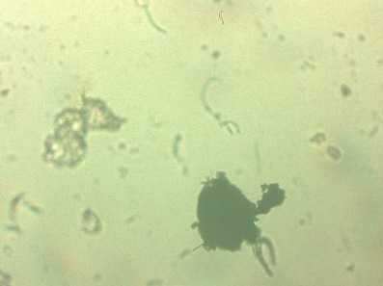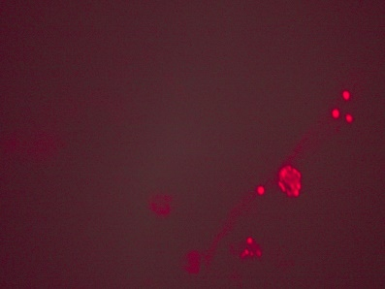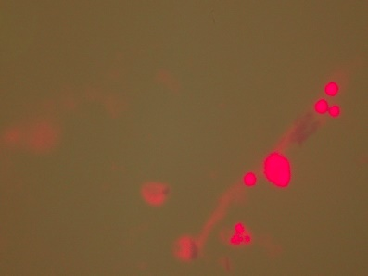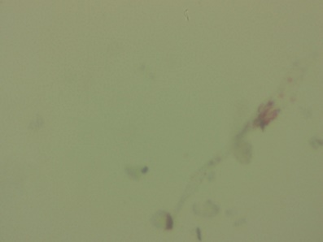
3a
3b
3c
2b
2a
2c
1a
1b
1c

Figure 5: Fluorescence microscopic images of MP fragments collected from the water sample taken from (1) central canal of Kandy, (Sri Lanka) (2), (3) Kandy Lake, Sri Lanka; stained with synthesized CdTe QDs, and observed under (a) visible light, (b) blue filter, (c) green filter

Under normal light (figures 5.1a, 5.2a, 5.3a), MP particles and fibers were less visible, as the fragments are often translucent or masked by debris, making them nearly impossible to quantify accurately. Once examined under blue (figures 5.1b, 5.2b, 5.3c) and green (figure 5.1c, 5.2c, 5.3c) excitation filters, QDs that were adhered to the surfaces of the plastics got excited and exhibited intense photoluminescence, allowing the fragments and fibers to be visible and be distinguished against the background matrix. This confirms the efficacy of CdTe QD labeling and proves that the optimized approach is effective for the rapid detection of MPs in real water samples.

- Conclusion
In this study, a fluorescence-based method for MP detection using 3-MPA and L-Ascorbic acid co-capped CdTe QDs was systematically evaluated and optimized through a comparative analysis of chemical pre-treatment strategies, incubation times, polymer types, and fluorescent probes. Among the tested conditions, HNO₃ pre-treatment followed by a 1-hour incubation period was identified as the most effective and time-efficient protocol, which provided consistent and strong fluorescence signals across the investigated plastic polymer types: PS, PP, PVC, and PE. While Nile Red remains the conventional standard CdTe QD labelling serves as a viable alternative, offering distinct advantages in terms of cost, versatility, and signal longevity. The inherent stability of QDs prevents the rapid degradation typically observed with organic stains, ensuring a reliable visualization of MP particles.
The successful application of the optimized protocol to environmental water samples further confirms its practical relevance and robustness in real-world conditions. Overall, this work highlights the potential of CdTe QDs as a reliable alternative fluorescent probe for MP detection and provides a rapid, polymer-independent labeling strategy that can support future environmental monitoring and analytical studies.
- References

1. Hartmann NB, Hu T, Thompson RC, Hassello M, Verschoor A, Daugaard AE, et al. Are We Speaking the Same Language ? Recommendations for a De fi nition and Categorization Framework for Plastic Debris. 2019;
2. Jolaosho TL, Rasaq MF, Omotoye EV, Araomo OV, Adekoya OS, Abolaji OY, et al. Microplastics in freshwater and marine ecosystems: Occurrence, characterization, sources, distribution dynamics, fate, transport processes, potential mitigation strategies, and policy interventions. Vol. 294, Ecotoxicology and Environmental Safety. Elsevier Inc.; 2025.
3. Karak P, Parveen A, Modak A, Adhikari A, Chakrabortty S. Microplastic Pollution: A Global Environmental Crisis Impacting Marine Life, Human Health, and Potential Innovative Sustainable Solutions. Int J Environ Res Public Health. 2025;22(6):1–22.
4. Everaert G, Rijcke M De, Lonneville B, Janssen CR, Backhaus T, Mees J, et al. Risks of fl oating microplastic in the global ocean. 2020;267.
5. Ofoegbu O, Onuwa PO, Kelle HI, Onogwu SU, Oluwadolapo J, Lullah-deh JA, et al. The Environmental and Health Implications of Microplastics on Human and Aquatic Life. 2024;IX(2454):367–77.
6. Elawady A, Amr J, Mohamed H, Abid M Bin. Journal of Hazardous Materials : Plastics Advancements in microplastics detection techniques and their multidimensional impacts on aquatic ecosystems and human health. J Hazard Mater Plast [Internet]. 2026;2(November 2025):100025. Available from: https://doi.org/10.1016/j.hazmp.2025.100025
7. Sturm MT, Myers E, Schober D, Korzin A, Schuhen K. Development of an Inexpensive and Comparable Microplastic Detection Method Using Fluorescent Staining with Novel Nile Red Derivatives. Analytica. 2023;4(1):27–44.
8. Shim WJ, Song YK, Hong SH, Jang M. Identification and quantification of microplastics using Nile Red staining. Mar Pollut Bull. 2016;113(1–2):469–76.
9. Kyoung Y, Hee S, Jang M, Myung G, Rani M, Lee J, et al. A comparison of microscopic and spectroscopic identification methods for analysis of microplastics in environmental samples. Mar Pollut Bull [Internet]. 2015;1–8. Available from: http://dx.doi.org/10.1016/j.marpolbul.2015.01.015
10. Araujo CF, Nolasco MM, Ribeiro AMP, Ribeiro-Claro PJA. Identification of microplastics using Raman spectroscopy: Latest developments and future prospects. Water Res. 2018;142:426–40.
11. Song YK, Hong SH, Jang M, Kang JH, Kwon OY, Han GM, et al. Large accumulation of micro-sized synthetic polymer particles in the sea surface microlayer. Environ Sci Technol. 2014;48(16):9014–21.
12. Vasudeva M, Warrier AK, Kartha VB, Unnikrishnan VK. Advances in microplastic characterization: Spectroscopic techniques and heavy metal adsorption insights. TrAC - Trends Anal Chem [Internet]. 2025;183(December 2024):118111. Available from: https://doi.org/10.1016/j.trac.2024.118111
13. Meyers N, Catarino AI, Declercq AM, Brenan A, Devriese L, Vandegehuchte M, et al. Microplastic detection and identification by Nile red staining: Towards a semi-automated, cost- and time-effective technique. Sci Total Environ [Internet]. 2022;823:153441. Available from: https://doi.org/10.1016/j.scitotenv.2022.153441
14. Maes T, Jessop R, Wellner N, Haupt K, Mayes AG. A rapid-screening approach to detect and quantify microplastics based on fluorescent tagging with Nile Red. 2017;(November 2016):1–10.
15. Utecht S, Krause S, Schuetz T. Particle size-dependent quantitative and qualitative differences of common microplastic detection procedures: Nile Red-assisted fluorescence microscopy and confocal micro-Raman spectroscopy. Environ Monit Assess [Internet]. 2025;197(8). Available from: https://doi.org/10.1007/s10661-025-14317-7
16. Ribeiro F, Duarte AC, Costa P. Trends in Analytical Chemistry Staining methodologies for microplastics screening. 2024;172(January).
17. Prata JC. Influence of intrinsic plastics characteristics on Nile Red staining and fluorescence. J Sea Res [Internet]. 2023;195(July):102431. Available from: https://doi.org/10.1016/j.seares.2023.102431
18. Abdulameer AF. Study of Optical and Structural Properties of CdTe Quantum Dots Capped with 3MPA Using Hydrothermal Method. 2022;6:842–50.
19. Carvalho MS, Mayrinck C, Raphael E, Bettini J, Ferraria JL, Schiavon MA. The role that electrolytes play in the synthesis of water-soluble cdte quantum dots prepared at ambient temperature. J Braz Chem Soc. 2017;28(7):1167–76.
20. Zou L, Gu Z, Zhang N, Zhang Y, Fang Z, Zhu W, et al. Ultrafast synthesis of highly luminescent green- to near infrared-emitting CdTe nanocrystals in aqueous phase †. 2008;2807–15.
21. Farias MDP, Albuquerque PBS, Soares PAG, de Sá DMAT, Vicente AA, Carneiro-da-Cunha MG. Xyloglucan from Hymenaea courbaril var. courbaril seeds as encapsulating agent of L-ascorbic acid. Int J Biol Macromol [Internet]. 2018;107:1559–66. Available from: http://dx.doi.org/10.1016/j.ijbiomac.2017.10.016
22. Erni-cassola G, Gibson MI, Thompson RC. Lost , but found with Nile red ; a novel method to detect and quantify small microplastics ( 20 µm – 1 mm ) in environmental samples. 2017;
23. Bakry A, Darwish MSA, Hassanein TF. Adsorption of methylene blue from aqueous solutions using carboxyl / nitro ‑ functionalized microparticles derived from polypropylene waste. 2022;185–97.
24. Sindhu G, Manikandan M, Dhanuskodi S, Arasu MMA. Scientific Research in Science and Technology ( IJSRST ) One-pot Synthesis of MPA Capped CdTe Quantum Dots for Non-Enzymatic Hydrogen Peroxide Biosensor Application International Journal of Scientific Research in Science and Technology ( IJSRST ). 2017;3(11):129–34.
25. De Moure-Flores F, Quiñones-Galván JG, Guillén-Cervantes A, Arias-Cerón JS, Hernández-Hernández A, Santoyo-Salazar J, et al. CdTe thin films grown by pulsed laser deposition using powder as target: Effect of substrate temperature. J Cryst Growth [Internet]. 2014;386:27–31. Available from: http://dx.doi.org/10.1016/j.jcrysgro.2013.09.036
26. Snee PT. The Role of Colloidal Stability and Charge in Functionalization of Aqueous Quantum Dots. Acc Chem Res. 2018;51(11):2949–56.
27. Vipulanandan C, Guezo YJA. Effects of temperature and strain rate on the tensile behavior of polypropylene composites insulator coatings used in offshore deepwater pipelines. 2017;45209:1–11.
28. Amelia RPD, Gentile S, Nirode WF, Huang L. Quantitative Analysis of Copolymers and Blends of Polyvinyl Acetate ( PVAc ) Using Fourier Transform Infrared Spectroscopy ( FTIR ) and Elemental Analysis ( EA ). 2016;4(2):25–31.
29. Ul-Hamid A, Soufi KY, Al-Hadhrami LM, Shemsi AM. Failure investigation of an underground low voltage XLPE insulated cable. Anti-Corrosion Methods Mater. 2015;62(5):281–7.

